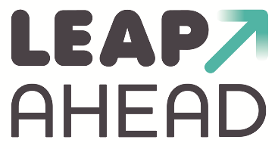

Unannounced Visit Record

Name of Childminder | Lisa Brooks (working with Adrian Fowler) | Childminder Agency Officer/s | Barbara Morton

Date of this visit | 15/2/19 | Date of last visit |  | U/V A/R

Reason for Visit | Scheduled UAV

Total number and age range of children currently cared for:
0 – 3 years
Number of:
Children drawing down funding | 1
Children with disabilities or SEN
Children from any groups who may be disadvantaged
Children entitled to the Early Years Pupil Premium
Children placed by the Local Authority
Who speak English as an additional language | 1

Since the agency’s last visit have any of your details changed (household members, children cared for, assistants, health etc.)? If so, please give the new details.
NA
Total children present: | Under 8 | 6 | Over 8 | 0

Topics Discussed/Observed (Safeguarding, SEN, EEF, Complaints, Concerns, Other)
Training
- All staff completed PFA 2/2/19 in –house
- SafeGuarding – Lisa will send through dates of last SG/child protection training
- Discussed attending LSCB face to face training – BM will send link
Development
- Lisa feels that all children are progressing well.
- Lisa has her key children and liaises with Adrian to share info and work on observations and assessments together
Working together
- As Lisa works within a large childminding setting she is aware of the need to liaise and share info across the team. There is a Whatsapp group for staff where information can be shared as well as staff meetings held every 2/3 months
Safeguarding
- Discussed whistleblowing – this area was discussed at the last team meeting where Suzanne (owner) and team discussed the process and what to do if they had concerns
- Discussed process for referral to SPA emphasising the need for speed and that it is better to contact SPA first before then informing the agency for cases where there are clear concerns
Health
- 2 children require Epipens – discussed their individual needs. Lisa has been required to administer the Epipen once.
- The children washed their hands before snack, the assistant ensured that the table was cleaned before and after
Website
- Lisa needs a log-in reset BM will complete

The setting is well laid out with a wide range of toys and resources for the children to choose from. There was a good balance of adult-led group times such as singing with child-initiated free play.
Snack time was sociable and the children and adults sat together whilst the children ate yoghurts, crackers, fruit and carrot sticks. The youngest children were supported to feed themselves where they were able.
The team work well together all understand the routines and quietly and efficiently get on with tasks.
BM observed positive, warm interaction between all adults and children. The children were encouraged to engage with each other and given time to express themselves verbally. It was a very language rich environment.

Area of Development | Action | Timescale
Observation and assessment | Continue to develop these and ensure that next steps are identified and followed up on | Next QAV

